API CRUD Testing Project – DummyJSON Products API

1. Introduction
This project demonstrates API testing of the DummyJSON Products API using Postman. The objective of this project is to validate the CRUD (Create, Read, Update, Delete) operations and negative scenarios to ensure the API behaves as expected.

2. Tools & Technologies Used
- Postman
- DummyJSON API
- JSON
- REST API concepts

3. Base URL
https://dummyjson.com/products
In the test, we used {{BASE URL}} =https://dummyjson.com/products

4. API Endpoints Tested
Feature | Endpoint | Purpose
Get All Products | GET /products | Retrieve all products from the DummyJSON API.
Get Single Product | GET /products/{id} | Retrieve details of a specific product by valid product ID.
Search Products | GET /products/search?q=phone | Search for products using a query parameter.
Get Categories | GET /products/categories | Retrieve a list of all product categories.
Add New Product | POST /products/add | Create a new product with valid JSON body.
Update Product | PUT /products/{id} | Update details of an existing product.
Delete Product | DELETE /products/{id} | Remove a product by its ID.
Error – Get Invalid Product | GET /products/195 | Validate error handling for non-existing product ID.
Error – Invalid POST Endpoint | POST /products/non_existent/add | Validate API behavior for an invalid route.
Error – Update Invalid Product | PUT /products/195 | Check error response for updating a non-existing product.
Error – Delete Invalid Product | DELETE /products/210 | Check error response for deleting a non-existing product.

5. Test Scenarios (CRUD)

GET All Products
Purpose: Validate that the API returns a list of all products.
Steps:
1. Open Postman.
2. Enter API endpoint.
3. Send request.
4. Validate response.
Expected Result: Response should match API specifications.
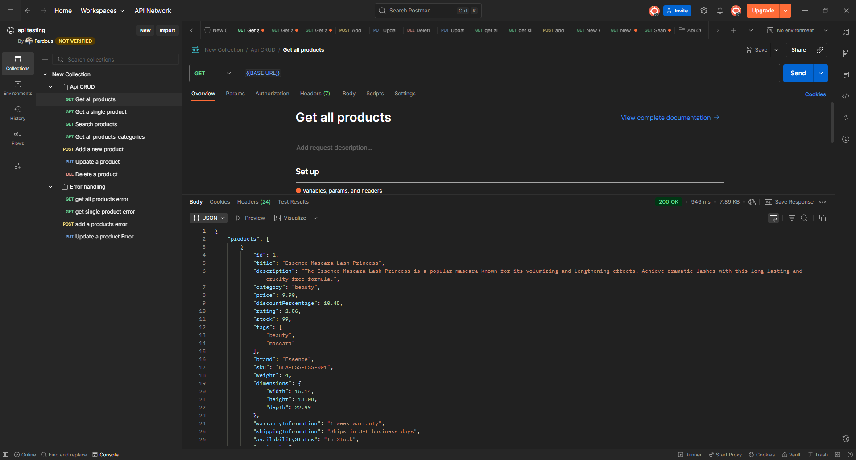

GET Single Product
Purpose: Validate that the API returns product details for a valid product ID.
Steps:
1. Open Postman.
2. Enter API endpoint.
3. Send request.
4. Validate response.
Expected Result: Response should match API specifications.
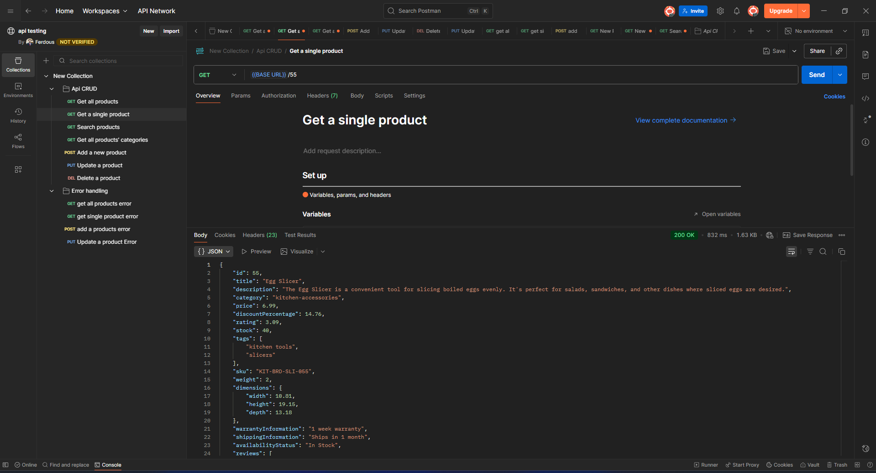

Search Products
Purpose: Verify the search functionality using query parameters.
Steps:
1. Open Postman.
2. Enter API endpoint.
3. Send request.
4. Validate response.
Expected Result: Response should match API specifications.
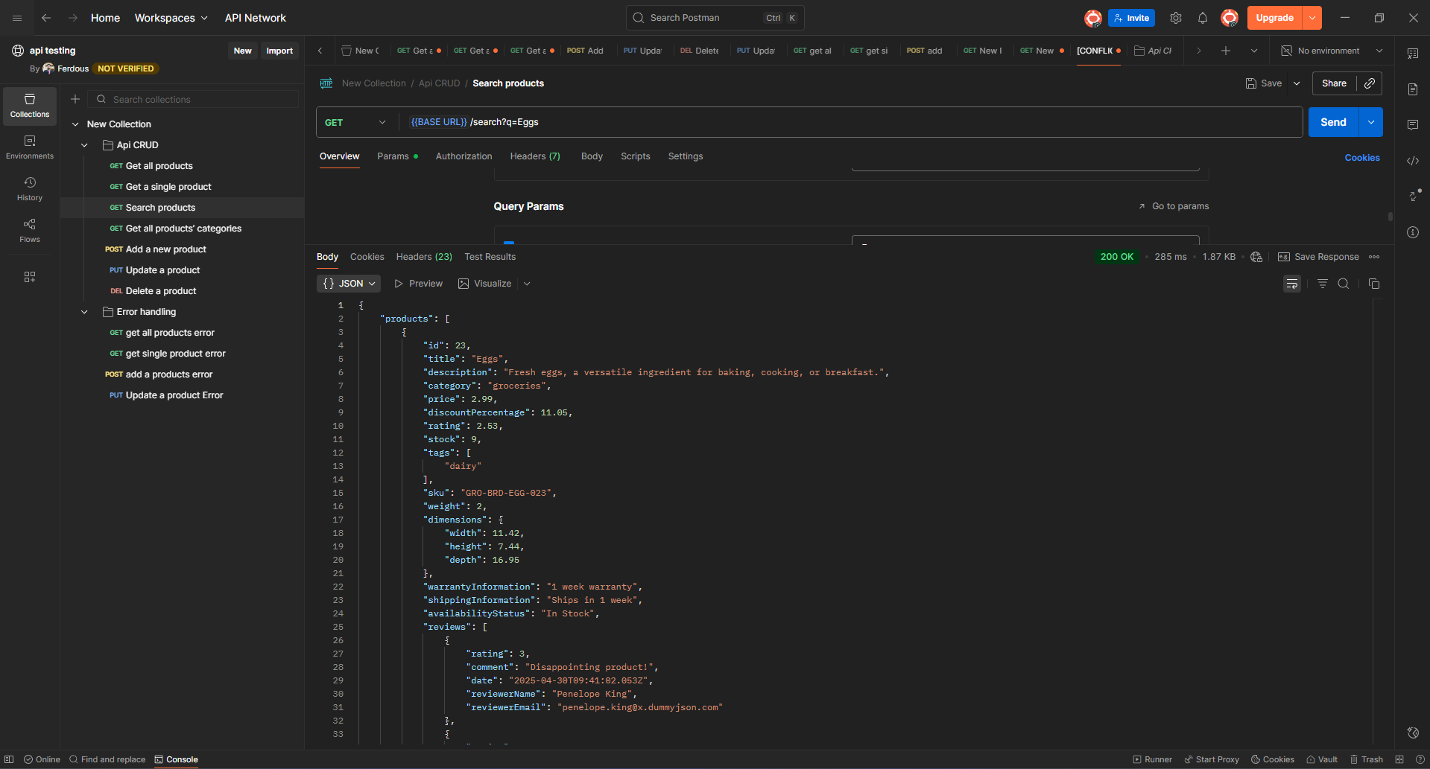

Add New Product (POST)
Purpose: Validate the creation of a new product using valid JSON input.
Steps:
1. Open Postman.
2. Enter API endpoint.
3. Send request.
4. Validate response.
Expected Result: Response should match API specifications.
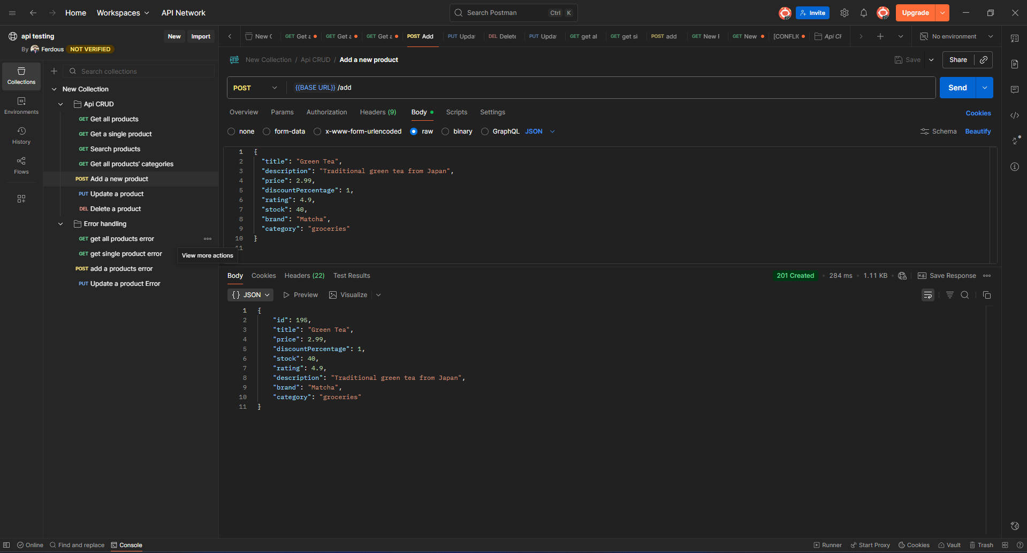

Update Product (PUT)
Purpose: Verify that an existing product can be updated successfully.
Steps:
1. Open Postman.
2. Enter API endpoint.
3. Send request.
4. Validate response.
Expected Result: Response should match API specifications.
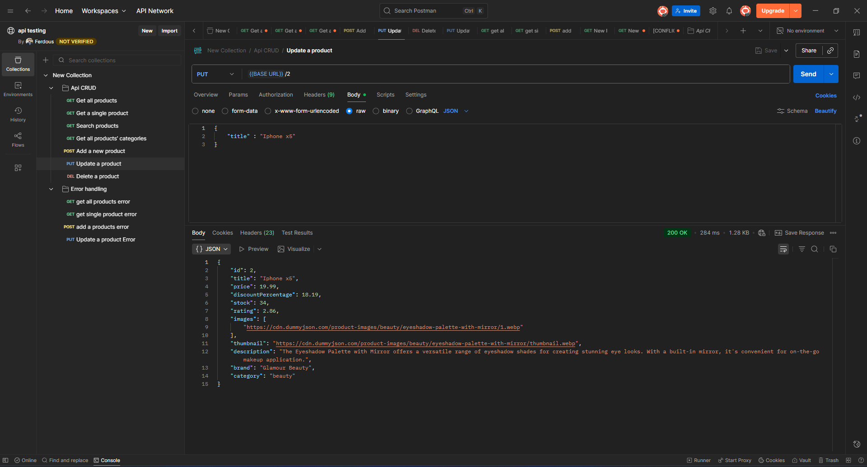

Delete Product (DELETE)
Purpose: Validate that a product is removed successfully.
Steps:
1. Open Postman.
2. Enter API endpoint.
3. Send request.
4. Validate response.
Expected Result: Response should match API specifications.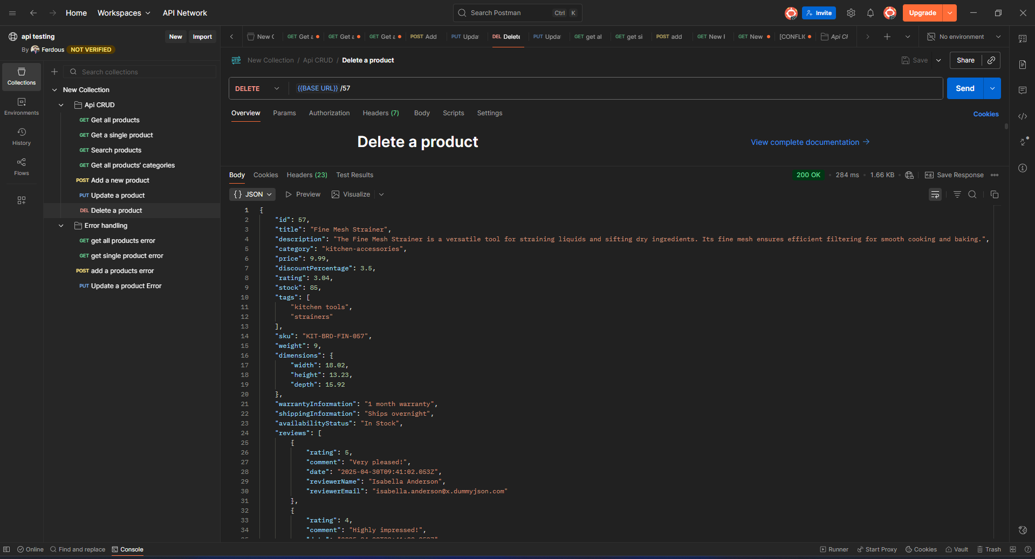

6. Negative / Error Test Cases
GET Single Product Error
Purpose: Validate that the API returns the correct error response when requesting a product with an invalid or non-existing product ID.
Steps:
- Open Postman.
- Enter the endpoint:
GET {{BASE URL}}195(or any non-existing ID).(Max ID was 194)
- Send the request.
- Observe and validate the error response.
Expected Result:
- API should return 404 Not Found.
- Response body should include an error message such as:
"message": "Product with id '195' not found"
- API should handle the error gracefully according to specifications
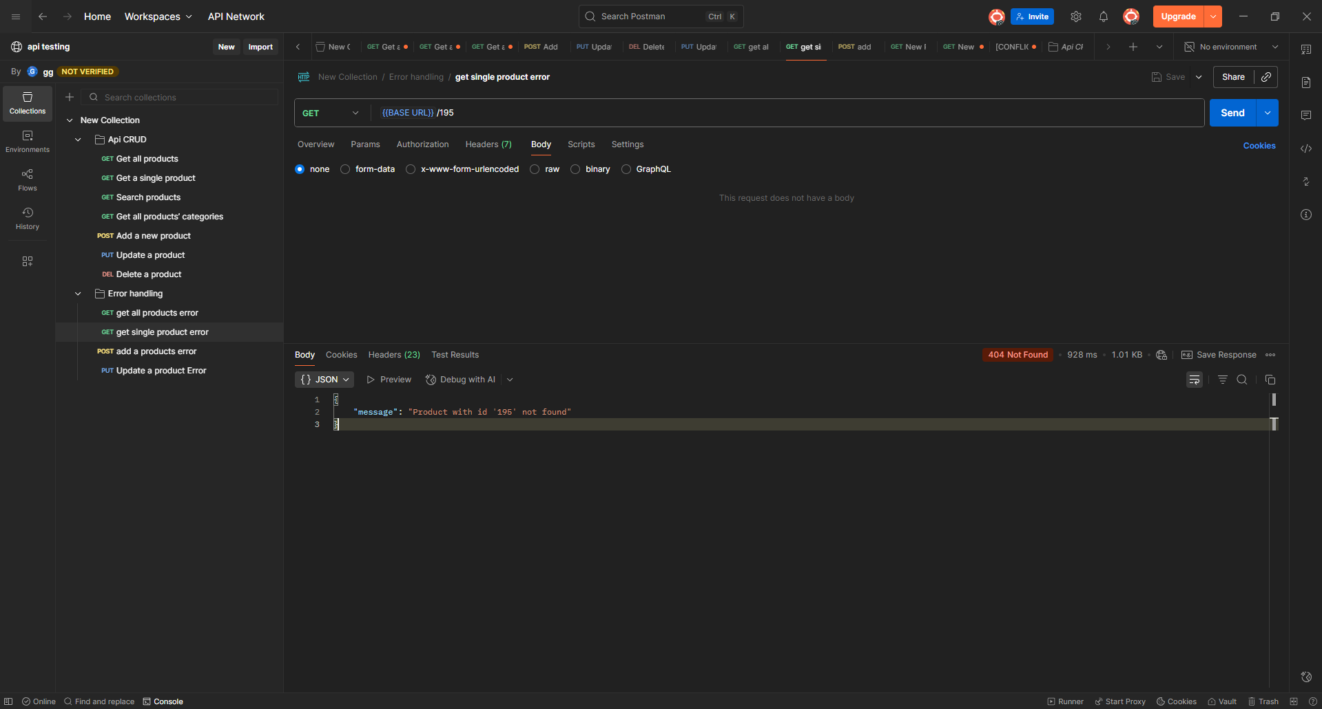
POST Add a Product Error
Purpose: Validate that the API returns the correct error response when attempting to create a product using an invalid or non-existent endpoint.
Steps:
- Open Postman.
- Enter the incorrect endpoint:
POST {{BASE URL}}/non_existent/add
(This endpoint does not exist in the DummyJSON API.)
- Send the request without a body.
- Observe and validate the error response shown in the response panel.
Expected Result:
- API should return 404 Not Found.
- Response body should display an error message similar to:
"Cannot POST /products/non_existent/add"
- API should clearly indicate that the endpoint is invalid.
- Error should be handled properly as per API specifications.

PUT Update a Product Error
Purpose:
Validate that the API returns the correct error response when attempting to update a product using an invalid or non-existing product ID.
Steps:
- Open Postman.
- Enter the endpoint:
PUT {{BASE URL}}/195
(Product ID 195 does not exist — maximum available ID is 194.)
- Keep or send any request body (optional, since ID itself is invalid).
- Send the request.
- Observe and validate the error response shown in the response panel.
Expected Result:
- API should return 404 Not Found.
- Response body should include an error message such as:
"message": "Product with id '195' not found"
- API should handle invalid update requests gracefully according to specifications.
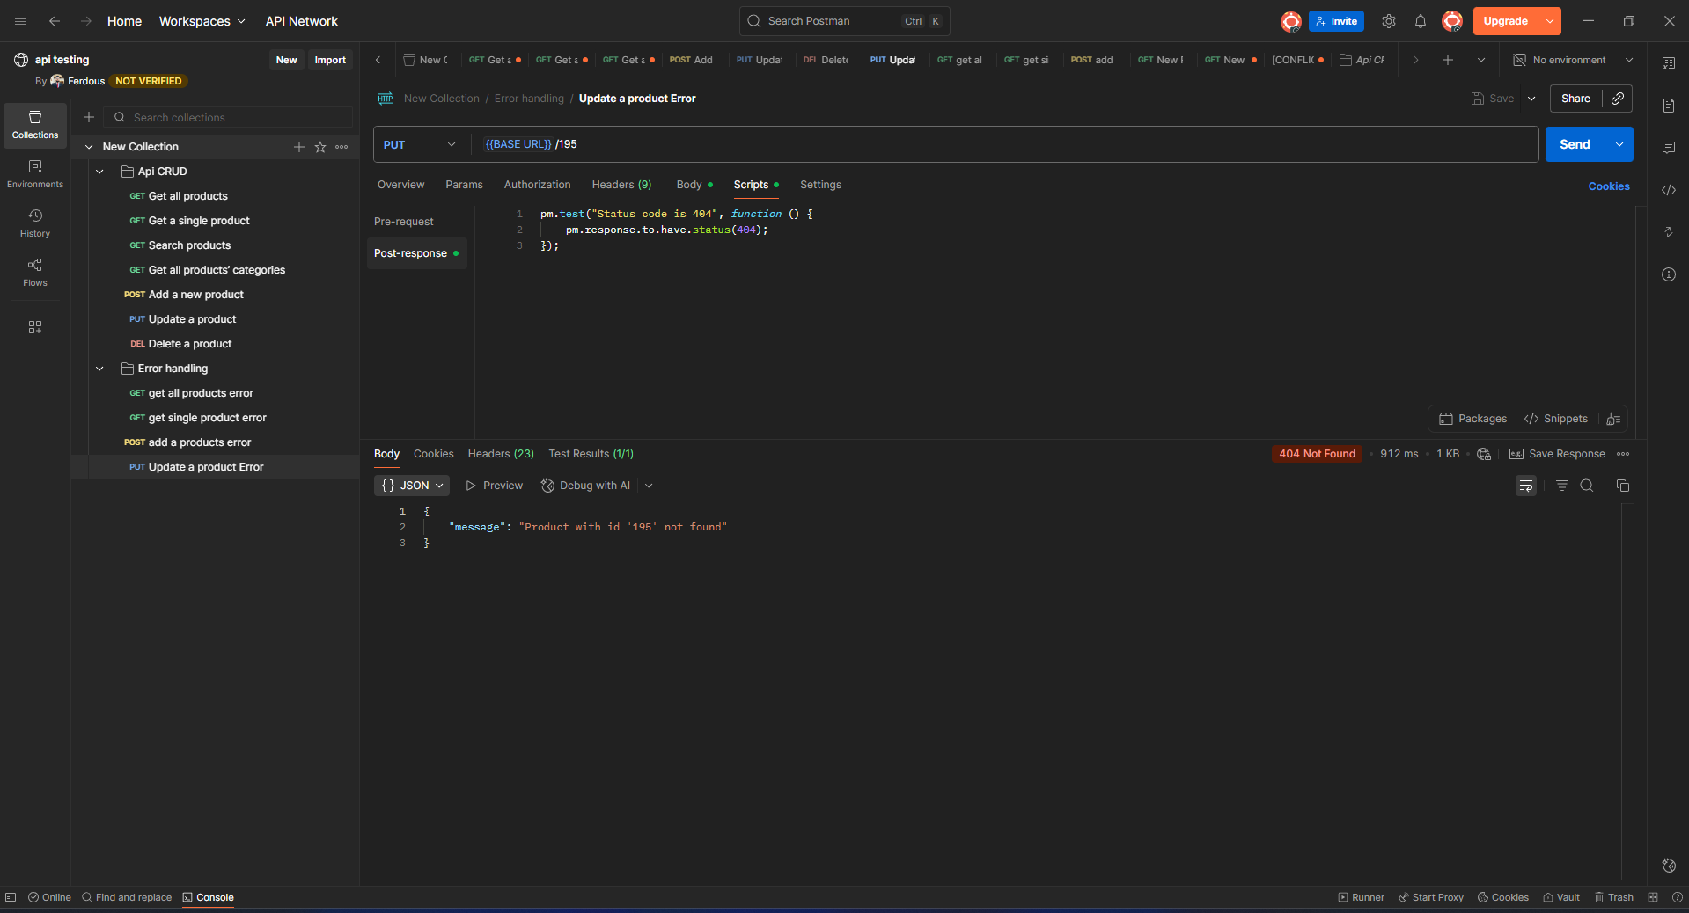

DEL Delete a Product Error
Purpose:
Validate that the API correctly returns an error when attempting to delete a product using an invalid or non-existing product ID.
Steps:
- Open Postman.
- Enter the endpoint:
DELETE {{BASE URL}}/210
(Product ID 210 does not exist — known max ID is lower.)
- Do not include any request body (DELETE does not require one).
- Send the request.
- Observe the error message in the response panel.
Expected Result:
- API should return 404 Not Found.
- Response body should include an error message such as:
"message": "Product with id '210' not found"
- API should properly handle deletion attempts for invalid IDs.
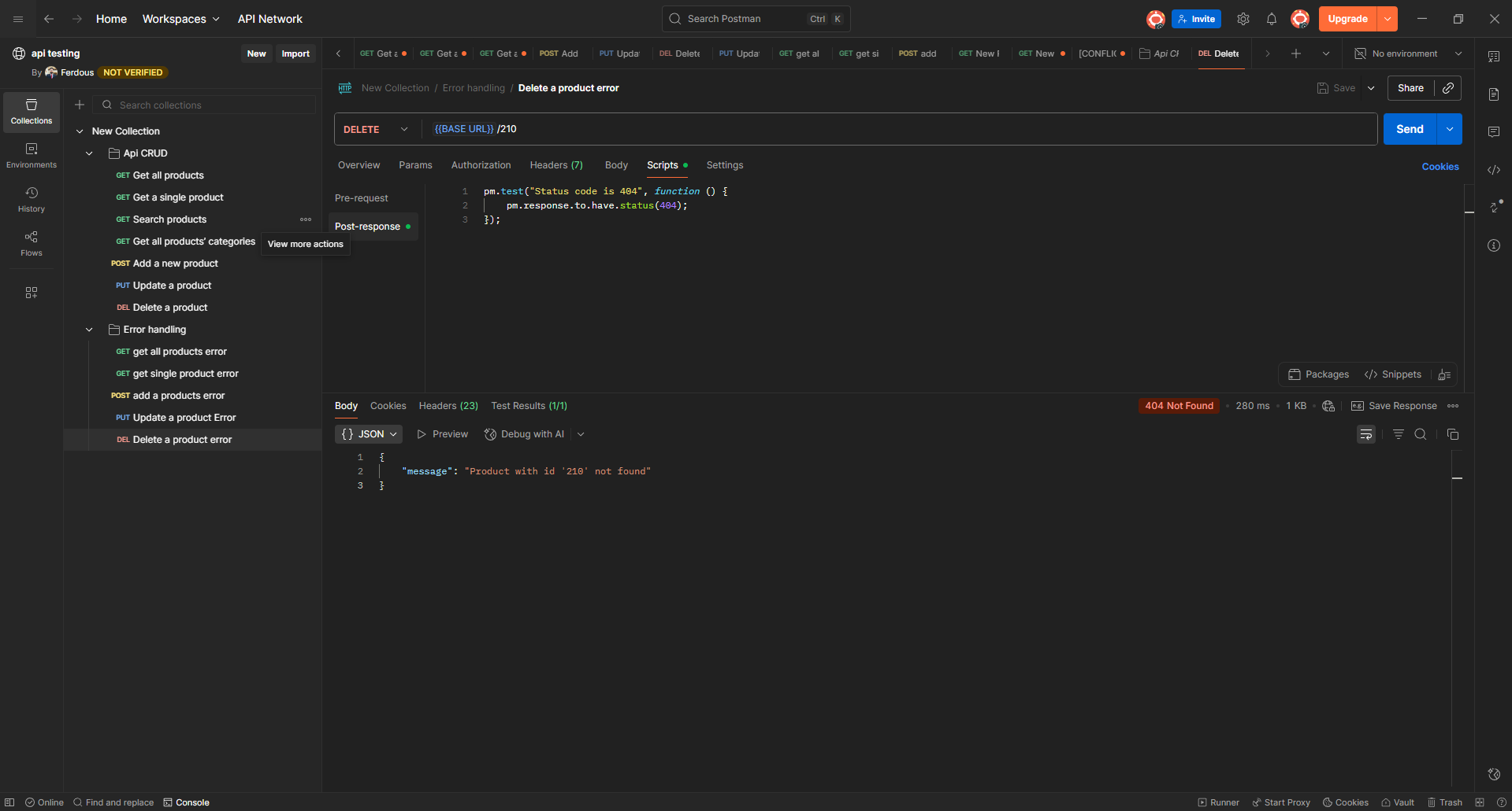

7. Test Results Summary
Test Case | Status
Get All Products | ✔ Passed
Get Single Product | ✔ Passed
Search Products | ✔ Passed
Get Categories | ✔ Passed
Add Product (POST) | ✔ Passed
Update Product (PUT) | ✔ Passed
Delete Product (DELETE) | ✔ Passed
Negative Test – Invalid Single Product (GET /195) | ✔ Passed
Negative Test – Invalid Endpoint (POST /non_existent/add) | ✔ Passed
Negative Test – Invalid Update (PUT /195) | ✔ Passed
Negative Test – Invalid Delete (DELETE /210) | ✔ Passed

8. Conclusion
This API testing project validates CRUD functionality and error handling for the DummyJSON Products API. It demonstrates understanding of REST API behavior, JSON handling, and Postman workflow. This document can be used as part of a QA portfolio.

